**Abstract**

For humans’ settlement on mars, it is necessary to design a propulsion system which has excellent specific impulse, reasonable operating cost, and plausible reusability capabilities. Most used propulsion system both historically and currently is chemical propulsion which uses energy released during chemical reaction of fuel and oxidizer to produce required thrust. However, the most advanced and most efficient chemical propulsion systems available to this date are still not capable and viable enough to carry out repeated space mission from earth to mars and beyond. Therefore, scientists and engineers are currently searching for alternative propulsion system which will meet all the demands and challenges of future ambitious space missions.

From the late 1950s to the early 1970s a major US program called NERVA (Nuclear Engine for Rocket Vehicle Application) successfully developed the capability to conduct space exploration using the advanced technology of nuclear rocket propulsion. A nuclear rocket propulsion or nuclear thermal rocket (NTR) is a type of thermal rocket where the heat from a nuclear reaction, often nuclear fission, replaces the chemical energy of the propellants in a chemical rocket. In an NTR, a working fluid, usually liquid hydrogen, is heated to a high temperature in a nuclear reactor and then expands through a rocket nozzle to create thrust. The program provided the basic reactor design, fuel materials development, and reactor testing capability. Surprisingly, designing a reactor to achieve criticality was the least of the problems. Innovative work had to be performed to store and pump liquid hydrogen, and to develop materials capable of withstanding the harsh environments both inside of the reactor core and external to the rocket engine. The radiation heating in the core and the surrounding structure had to be considered as well as the environment external to the engine. Everything inside of the core and surrounding structure had to be cooled, and heating was inconsistent during operation. Finally, the exhaust (or propellant) gas temperature needed to be maximized.

The results of numerous studies over the past 50 years have described the advantages of nuclear heat exchanger rocket engines. The bottom line—high thrust and specific impulse (). Although there are systems such as ion propulsion that have higher specific impulse, and other systems that offer higher thrust, there is nothing that provides the unique combination of relatively high thrust and high specific impulse. In this report characteristics of NTR system such as its specific impulse, thrust capability, hydrogen mass flow rate and efficiency of each component in the system are modeled and simulated based on real life data and previous experimental results. The operation of the nuclear reactor was considered largely as a black-box model, and key operating parameters such as temperatures and heat flows were based on the results of NERVA program and current proposed design for a small scale NTR.

The report is structured in different modelling and simulation steps, starting with the mind model of the entire system and its working, which provides a brief description of each process and how overall model will behave during simulation task. This step helps in building the conceptual understanding of what we are trying to model and what is the output that we wish to get after we perform simulation task.

The second step of modelling was to construct a physical model which provides more in-depth understanding of each process and associated components and consisted of an analysis of the different physical phenomena in the cycle, the model complexity, the degrees of freedom as well as the  
model types. Third step was to develop a mathematical model where all required equations are given and explained. The final step of modelling was to develop a Numerical model where these equations are solved, and output of simulation is acquired.

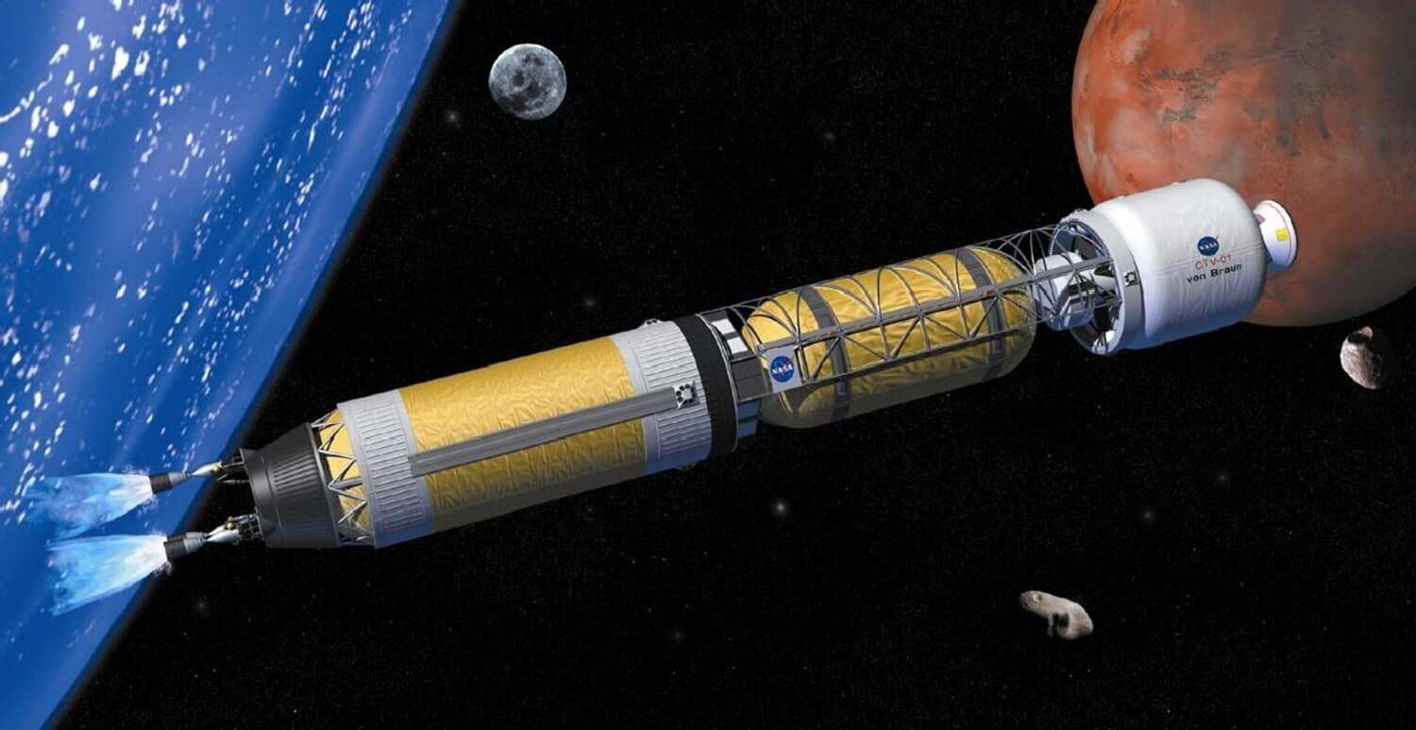

**Contents**

**1 Introduction 1  
2 Methods 1**2.1 Mind Model 1  
2.1.1 System Level . . . . . . . . . . . . . . . . . . . . . . . . . . . . . . . . . . . . . . . 1  
2.1.2 Component Level . . . . . . . . . . . . . . . . . . . . . . . . . . . . . . . . . . . . . 5  
2.1.3 Control Strategy and Feedback Loops . . . . . . . . . . . . . . . . . . . . . . . . . 10  
2.2 Physical Model . . . . . . . . . . . . . . . . . . . . . . . . . . . . . . . . . . . . . . . . . . 12  
2.2.1 Model Complexity . . . . . . . . . . . . . . . . . . . . . . . . . . . . . . . . . . . . 12  
2.2.2 Selected Phenomena . . . . . . . . . . . . . . . . . . . . . . . . . . . . . . . . . . . 14  
2.2.3 Model Types . . . . . . . . . . . . . . . . . . . . . . . . . . . . . . . . . . . . . . . 14  
2.2.4 Degrees of Freedom . . . . . . . . . . . . . . . . . . . . . . . . . . . . . . . . . . . 14  
2.3 Mathematical model . . . . . . . . . . . . . . . . . . . . . . . . . . . . . . . . . . . . . . . 16  
2.3.1 Rankine Cycle . . . . . . . . . . . . . . . . . . . . . . . . . . . . . . . . . . . . . . 16  
2.3.2 Molten Salt Storage . . . . . . . . . . . . . . . . . . . . . . . . . . . . . . . . . . . 22  
2.3.3 Transient Model . . . . . . . . . . . . . . . . . . . . . . . . . . . . . . . . . . . . . 22  
2.4 Numerical Model and Test of Numerics . . . . . . . . . . . . . . . . . . . . . . . . . . . . 24  
2.4.1 Design Model . . . . . . . . . . . . . . . . . . . . . . . . . . . . . . . . . . . . . . . 24  
2.4.2 Operational Model . . . . . . . . . . . . . . . . . . . . . . . . . . . . . . . . . . . . 24  
2.4.3 Transient Model . . . . . . . . . . . . . . . . . . . . . . . . . . . . . . . . . . . . . 25  
2.5 Verification . . . . . . . . . . . . . . . . . . . . . . . . . . . . . . . . . . . . . . . . . . . . 26  
**3 Results 26**3.1 Design Model . . . . . . . . . . . . . . . . . . . . . . . . . . . . . . . . . . . . . . . . . . . 26  
3.2 Operational Model . . . . . . . . . . . . . . . . . . . . . . . . . . . . . . . . . . . . . . . . 28  
3.3 Molten Salt Storage . . . . . . . . . . . . . . . . . . . . . . . . . . . . . . . . . . . . . . . 29  
3.4 Transient Model . . . . . . . . . . . . . . . . . . . . . . . . . . . . . . . . . . . . . . . . . 31  
**4 Conclusion 33  
5 References 35  
6 Appendix 36**

1. **Introduction**

The present work focuses rather synthetically on NP (Nuclear propulsion) based on fission. (Fusion has been demonstrated, but the net power gain budget is still negative, and power generation is still far in the future, so NP based on this technology will not be discussed.) Note that only reluctantly space agencies or international study groups like ISECG [ISECG] are beginning to include *fission-based NP* in their exploration scenarios. The cost of R&D and experimenting with NP technology is in fact much higher than with conventional rocket propulsion, and until now MIR first, and then ISS, have absorbed most of the human exploration R&D moneys. Even though NP has its great advantages it is important to mention in the beginning of this report, that one of the key disadvantages of NP is that it can’t produce enough thrust to exit the earth surface, thus nuclear propulsion-based rockets will be launched into space by chemical rockets before they are turned on.

The purpose of this project is to construct a digital model of nuclear thermal propulsion rocket engine using numerical tools incorporating fundamental equations along with historical and recently known facts and then to determine whether we can optimize certain components and processes within NP rocket engine that will provide us with maximum efficiency not only in terms launching cost but also in terms of distance it can travel per kilogram of propellant. However, the optimization part is mostly concerned with thermodynamical processes and not with the mechanical structure and nuclear reactor design. The optimization will be performed by simulating the functional model by inputting a range of input parameters and then evaluating the generated output in terms of its feasibility and practicality.

Therefore, following simulation objective is defined –

**“**

1. **Methods**
   1. **Mind model**

Working of NTP engine in brief (overview of all the process and components involved) –

1. The liquid hydrogen stored in insulating container is pumped into the cavities inside the main nozzle.
2. The liquid hydrogen then travels upwards through the neutron reflector surrounding the reactor core, cooling both the reflector and the control drums contained within it, and through a neutron and gamma ray shield placed at the upper end of the reactor assembly to limit the radiation-heating of propellant in the tank.
3. Flowing downward, the propellant cools the reactor support structure and is heated to the design temperature, exiting into the nozzle plenum chamber prior to being discharged through the exhaust nozzle.
4. Some propellant is bled off from this chamber and is cooled to an acceptable inlet temperature for the pump drive turbine. This cooling is accomplished primarily by mixing the heated material with cold fluids. A small amount of gas is also drawn from a convenient region of the engine, such as the reactor core inlet plenum, for pressurization of the propellant tank and operation of pneumatically actuated control system components.

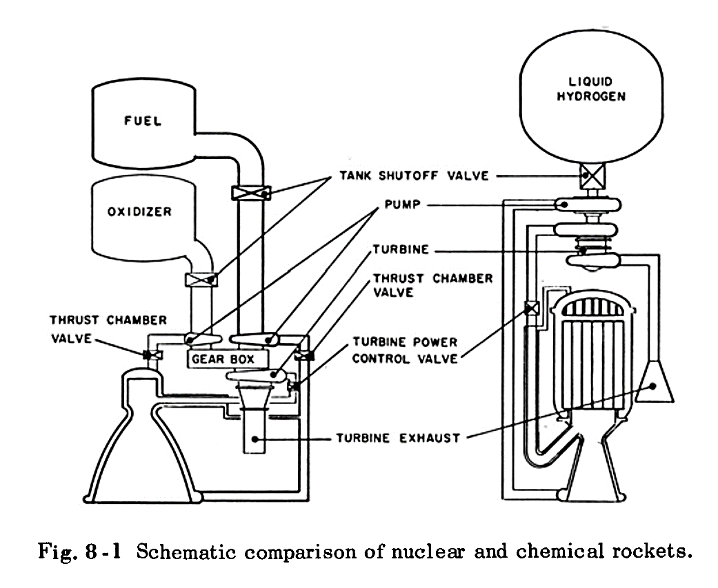

Figure - A comparison between working of chemical rocket (on right) and nuclear thermal rocket (on left)

Further within the scope of mind model, we investigate three different sub-level.

* + 1. **System level**

First subsystem consists of pumping cycle where liquid hydrogen from the liquid hydrogen storage tank enters the tank shut off control valve at low pressure and low mass flow rate and is then sucked inside pump through pump inlet where its pressure and mass flow rate are increased quite substantially. Adjusting the control valve results in less or more flow of hydrogen from storage tank to the pump inlet. This way we can control the thrust and specific impulse of the rocket. The

The second subsystem includes heat exchanger which exchanges heat between liquid hydrogen exiting from pump outlet and entering the nozzle and reactor outer body.

The third sub-system includes the nuclear reactor core, which produces heat through the fission process of fissile fuel. Compact NTR reactors require the use of fuel which is highly enriched in U235 and that can also sustain temperatures as high as 3000 K for the duration of a mission, where a typical mission to Mars requires 4 rocket burns for a cumulative burn time of approximately 2 hours. In the NERVA programs, highly enriched uranium was chosen as the fuel and the fuel elements were tested to temperatures as high as 2700 K with hydrogen outlet temperatures of approximately 2600 K. However, recently low enriched uranium tungsten Ceramic-Metallic fuels were produced which contained 60 vol.% UO2 and were successfully tested at temperatures as high as 3000 K. The reactor contains multiple coolant channels which acts as a heat exchanger that is responsible for transferring the heat from the reactor to the hydrogen. A representation of the reactor subsystem is given in Figure 2. Note that in the sketch of figure 2, only the part that lies within the red line is relevant for the first sub-system in this project. The reactor part will be treated as a “Gray box” in this project and thus only the heat exchanger part along with heat production, 450 MWth, and relevant temperatures and pressures mentioned above are relevant for the analysis.

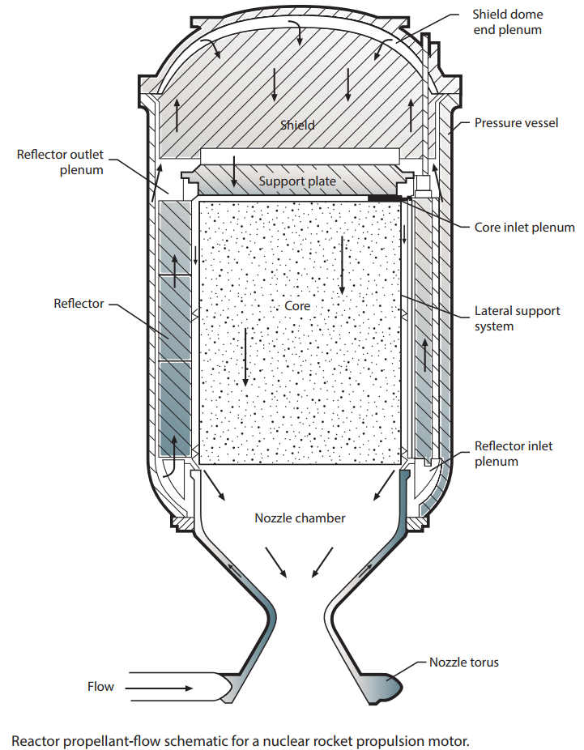

Figure - The nuclear reactor sub-system with the relevant temperatures and pressures

Turbine and electrical generator constitutes fourth subsystem. The hot hydrogen gas which is bled off from the reactor outlet plenum is mixed with cold hydrogen from the enters the turbine and spins it blade at very high velocity.

Fifth subsystem consists of expansion of hot hydrogen gas in the nozzle and production of thrust

* + 1. **Component level**
       1. **Nuclear reactor**

A Nuclear Thermal Propulsion reactor consists of six primary components, which are the axial neutron reflector, fission fuel, radial neutron reflector, inner and outer pressure vessels, and control drums. The fuel elements and axial neutron reflector are combined into one item and are fabricated to be hexagonal in cross section. In the technical report of the reactor, it is stated that the hot hydrogen enters the heat exchanger at 704 and exits at 565, without experiencing a phase change

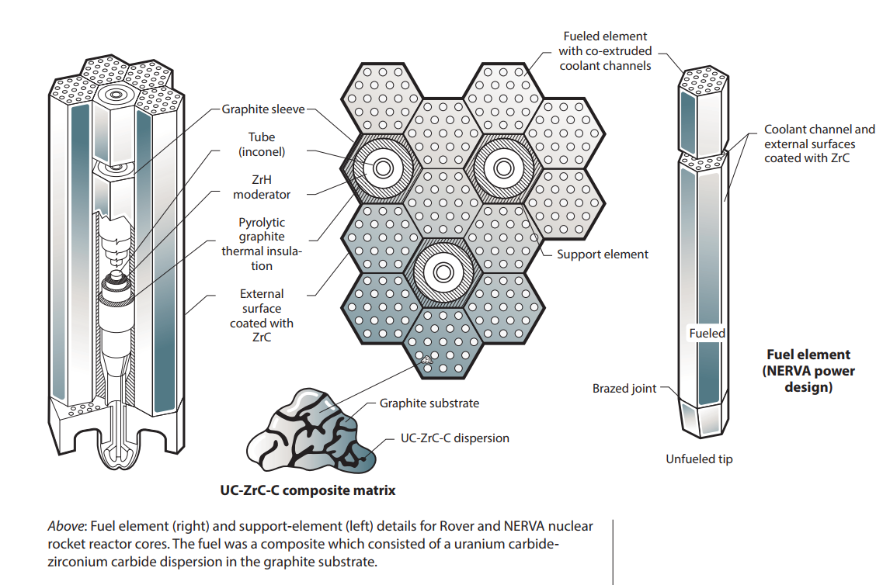

* + - 1. **Hydrogen storage tank**

To keep hydrogen from evaporating or boiling off, rockets fueled with liquid hydrogen must be carefully insulated from all sources of heat, such as rocket engine exhaust and air friction during flight through the atmosphere. Once the vehicle reaches space, it must be protected from the radiant heat of the Sun. When liquid hydrogen absorbs heat, it expands rapidly; thus, venting is necessary to prevent the tank from exploding. Metals exposed to the extreme cold of liquid hydrogen become brittle. Moreover, liquid hydrogen can leak through minute pores in welded seams.

We considered a 500,000-gallon hydrogen tank for modelling which will later be replaced by a variable volume for simulation purpose. In this study, foam/MLI combination insulation system is selected for a cryogenic liquid hydrogen tank. The spray-on foam layer is directly applied to the tank wall with an average thickness of 6.0 cm, which is verified to avoid air liquefaction. A 30-layer MLI is covered on the spray-on foam insulation. The MLI layer is composed of multiple double-aluminized Mylar radiation shields with Dacron spacer material being the separator between any two shields. Meanwhile, the radiation shield is perforated with substantial micropores for successful venting during ascent to orbit.

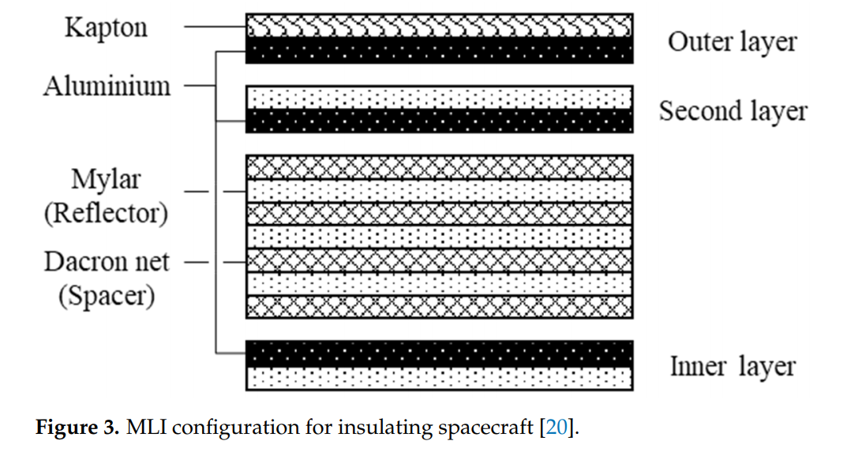

* + - 1. **Turbine**

The turbine will generally be a one- or two-stage unit designed to handle all or nearly all of the pumped fluid. The turbine inlet temperature generally ranges between, and , so light alloys can be used. The turbine must be matched to the pump requirements in speed and power output. Minimum weights are usually obtained if direct coupled, equal-speed systems are used.

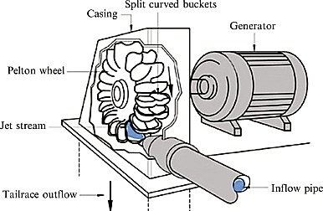

* + - 1. **Pump**

The purpose of the pump is to increase the pressure of the liquid hydrogen propellant from its pressure level in the supply tank to the pressure required by the engine system. This is achieved by doing work on liquid hydrogen via impeller action. One of the most important factors in designing a rocket pump, particularly for a hydrogen system, is **the magnitude of** **the net positive suction pressure, NPSP.** In most pumping systems, the available NPSP limits the driving pressure that accelerates the fluid from its static condition in the tank to the pump inlet speed. Two general classes of pumps are available for use in a nuclear rocket engine: (1) multiple-stage axial flow; and (2) single- or multiple-stage centrifugal flow.

|  |  |  |
| --- | --- | --- |
|  | **Multi-stage centrifugal flow** | **Multi-stage axial flow** |
| **1** | **Suction characteristics** of centrifugal pumps are, in general, **superior to those of axial flow pumps.** | **Suction is not as powerful as centrifugal pump** however, the addition of an inducer section upstream of the forward bearing mount (overhung position), results in identical suction characteristics with both types. |
| **2** | Not that efficient as axial pump however **efficiency has not been the paramount factor in** **rocket engine pump design** to date. Suction performance, low weight, and high reliability have been the most important design requirements. For instance, in a topping-cycle nuclear rocket engine, **the pump efficiency has only a negligible effect on overall vehicle performance.** | **The axial-flow pump is expected to be more efficient than the corresponding centrifugal pump.** The margin should be greater for design applications requiring very high discharge pressure and will be reduced under more difficult suction operating conditions. |
| **3** | **The operating point does not need to be close to the stall line for centrifugal-flow** pumps which can have their operating point far removed from the stall region. When a nuclear rocket engine is performing at less than the design thrust level but at maximum core exit gas temperature, the pump operating point moves toward lower specific speed and toward the surge region. **Since a wider margin is available, this potential operating condition could best be met with the centrifugal pump.** | To operate the axial-flow pump at near-maximum efficiency, **the operating point must be close to the stall line;** therefore, this pump must be carefully matched to the load characteristics. |

Considering the above factors and the current state of hydrogen-pump technology, the centrifugal pump is more adaptable to nuclear rocket engine configurations and will be used for further modeling and simulation purpose.

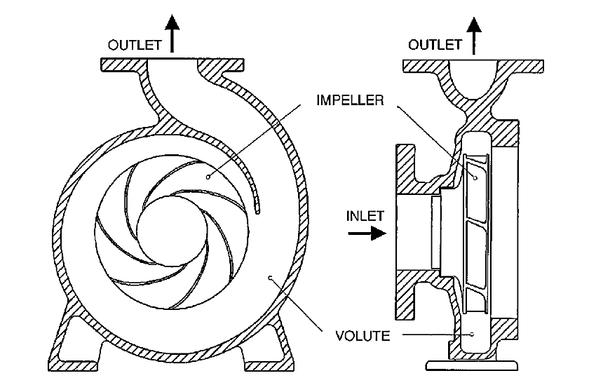

* + - 1. **Exhaust nozzle –**

A rocket engine uses a nozzle to accelerate hot exhaust to produce thrust as described by Newton's third law of motion. The amount of thrust produced by the engine depends on the mass flow rate through the engine, the exit velocity of the flow, and the pressure at the exit of the engine. The value of these three flow variables are all determined by the rocket nozzle design.

A nozzle is a relatively simple device, just a specially shaped tube through which hot gases flow. Rockets typically use a fixed convergent section followed by a fixed divergent section for the design of the nozzle. This nozzle configuration is called a convergent-divergent, or CD, nozzle. In a CD rocket nozzle, the hot exhaust leaves the combustion chamber and converges down to the minimum area, or throat, of the nozzle. The throat size is chosen to choke the flow and set the mass flow rate through the system. The flow in the throat is sonic which means the Mach number is equal to one in the throat. Downstream of the throat, the geometry diverges, and the flow is isentropically expanded to a supersonic Mach number that depends on the area ratio of the exit to the throat. The expansion of a supersonic flow causes the static pressure and temperature to decrease from the throat to the exit, so the amount of the expansion also determines the exit pressure and temperature. The exit temperature determines the exit speed of sound, which determines the exit velocity. The exit velocity, pressure, and mass flow through the nozzle determines the amount of thrust produced by the nozzle.

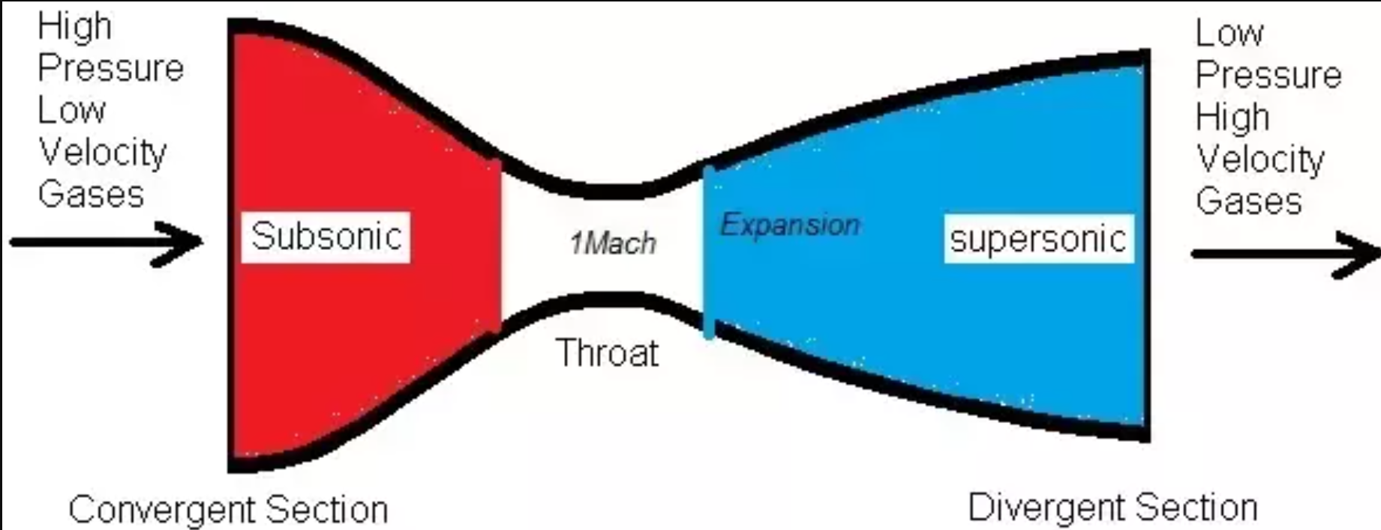

* + 1. **Control strategy and feedback loop**

The control system of a nuclear rocket engine is significantly more complex than that of a chemical rocket, primarily because the reactor power level is completely independent of engine thrust. A nuclear rocket engine control system consists of two separate control loops: one for the propellant feed system and one for reactor power.

* 1. **Physical model**
     1. **Model complexity**
     2. **Selected phenomena**
     3. **Model types**
     4. **Degree of freedoms**
  2. **Mathematical model**
     1. **Assumptions**
     2. **Open cycle equations**

**2.3.2.1 Thrust of rocket**

Input variables –

Distance to be travelled

Time to reach the destination

Maximum g’s human can handle or required acceleration for rocket

Initial velocity during stage separation

Mass of rocket at given time

Output variables –

The duration of time nuclear rocket needs to produce thrust

Required thrust of the rocket

Required equations –

**2.3.2.2 Specific impulse of rocket**

* + 1. **Component equations**

**2.3.3.1 Hydrogen tank equation**

Input variables –

Tank storage volume

Initial volume of liquid hydrogen in tank

Initial mass of entire tank

Total resistance of the insulation layer

Heat flux expected due to radiation

Mass flow rate of liquid hydrogen

Time to reach space

Output variables –

Tank inside temperature and pressure at given time

Volume of liquid hydrogen left in the tank at given time

Mass of entire tank at given time

Required equations –

**2.3.3.2 Nozzle equations**

Input variables –

Nozzle throat area

Nozzle exit area

Output variables –

**2.3.3.3 Pump equations**

**2.3.3.4 Turbine equations**

**2.3.3.5 Nuclear reactor heat exchanger equations**

Input variables –

Incoming mass flow rate

Number of channels

Temperature of core

Output variables –

Outgoing mass flow rate

Enthalpy of outgoing liquid hydrogen

**2.3.3.6 Radiation shield and Nozzle plumbing heat exchanger equations**

* 1. **Numerical model and test of numeric**
     1. **Design model**
     2. **Operational model**
     3. **Transient model**
  2. **Verification**

1. **Results**
2. **Conclusion**

NP is an outstanding, if not *the* outstanding propulsion candidate for deep space human missions to Mars and possibly also to NEA (Near earth asteroid), although future high efficiency solar panels might become a good competitor. Because of its inherent power density NP is capable of reducing drastically travel time and thus crew radiation dose, with its known and newly emerging health risks.

With the results demonstrated in this and various other reports, we can undoubtedly conclude that

1. **Definitions and terminologies**
2. Specific impulse – Specific impulse is the amount of push the rocket gets by burning per unit propellant.
3. The thermal and hydraulic design – of the reactor core provides adequate heat transfer compatible with the heat generation distribution in the core. This provides adequate heat removal by the reactor coolant system, the normal residual heat removal system, or the passive core cooling system.
4. Impeller – An impeller or impellor is a rotor used to increase the pressure and flow of a fluid. It is the opposite of a turbine, which extracts energy from, and reduces the pressure of, a flowing fluid.
5. Plenum chamber – A plenum chamber is a pressurized housing containing a fluid (typically air) at positive pressure. One of its functions is to equalize pressure for more even distribution, compensating for irregular supply or demand.
6. A neutron reflector – is any material that reflects neutrons. This refers to elastic scattering rather than to a specular reflection. The material may be graphite, beryllium, steel, tungsten carbide, gold, or other materials. A neutron reflector can make an otherwise subcritical mass of fissile material critical or increase the amount of nuclear fission that a critical or supercritical mass will undergo.
7. A turbopump – is a propellant pump with two main components: a rotodynamic pump and a driving gas turbine, usually both mounted on the same shaft, or sometimes geared together.
8. A rotodynamic pump – is a kinetic machine in which energy is continuously imparted to the pumped fluid by means of a rotating impeller, propeller, or rotor, in contrast to a positive displacement pump in which a fluid is moved by trapping a fixed amount of fluid and forcing the trapped volume into the pump's discharge.
9. MLI – Multilayer Insulation (MLI) is one composite material which consists of many radiation shields separated by low conductivity spacer or insulation.
10. **References**